**LAMPIRAN LISTING PROGRAM**

## **Calon.php**

|  |
| --- |
| <?php  defined('BASEPATH') or exit('No direct script access allowed');  class Calon extends MX_Controller{  public function __construct(){  parent::__construct();  is_logged_in_admin();  $this->load->model('CalonModel');  $this->load->model('ParpolModel');  $this->load->model('PeriodeModel');  $this->load->model('PemilihModel');  }  public function index(){  $data['title'] = 'Data Calon Pilkada';  $data['calon'] = $this->CalonModel->semuaCalon();  adminView('calon/index', $data);  }  public function acak_nourut(){  $calons = $this->CalonModel->calonPeriodeAktif();  $i = 1;  foreach ($calons as $calon) {  $this->CalonModel->updateNoUrut($calon['id_calon'], $i);  $i++;  }  $this->session->set_flashdata('success', 'No urut calon pilkada berhasil diacak');  redirect('admin/calon');  }  public function form_calon($id = null){  $data['title'] = 'Tambah Calon Pilkada';  $data['periode'] = $this->PeriodeModel->semuaPeriode();  $data['pemilih'] = $this->PemilihModel->semuaPemilih();  $data['parpol'] = $this->ParpolModel->semuaParpol();  if ($id) {  $data['title'] = 'Edit Calon Pilkada';  $data['detail'] = $this->CalonModel->calonById($id);  }  adminView('calon/form_calon', $data);  }  public function simpan_calon(){  $this->form_validation->set_rules('id_ketua', 'Ketua', 'trim|required');  $this->form_validation->set_rules('id_wakil', 'Wakil Ketua', 'trim|required');  $this->form_validation->set_rules('kategori', 'Kategori', 'trim|required');  $this->form_validation->set_rules('visi_misi', 'Visi dan Misi', 'trim|required');  if ($this->form_validation->run() == FALSE) {  redirect('admin/calon');  } else {  if ($this->input->post('submit') == "Tambah") {  if ($this->CalonModel->tambahCalon()) {  $this->session->set_flashdata('success', 'Data Calon Pilkada Berhasil Ditambah');  } else {  $this->session->set_flashdata('danger', 'Data Calon Pilkada Gagal Ditambah');  }  } else {  if ($this->CalonModel->editCalon()) {  $this->session->set_flashdata('success', 'Data Calon Pilkada Berhasil Diedit');  } else {  $this->session->set_flashdata('danger', 'Data Calon Pilkada Gagal Diedit');  }  }  redirect('admin/calon');  }  }  public function hapus_calon($id_calon){  $calon = $this->CalonModel->calonById($id_calon);  if ($calon) {  if ($this->CalonModel->hapusCalon($id_calon)) {  if ($calon['photo'] != "defaultcalon.png") {  $img_file = "./assets/images/calon/" . $calon['photo'];  unlink($img_file);  }  $this->session->set_flashdata('success', 'Data Calon Pilkada Berhasil Dihapus');  } else {  $this->session->set_flashdata('danger', 'Data Calon Pilkada Gagal Dihapus');  }  }  redirect('admin/calon');  }  } |

## **Pemilih.php**

|  |
| --- |
| <?php  defined('BASEPATH') or exit('No direct script access allowed');  class Pemilih extends MX_Controller{  public function __construct(){  parent::__construct();  is_logged_in_admin();  $this->load->model('PemilihModel');  }  public function index(){  $data['title'] = 'Data Pemilih';  $data['pemilih'] = $this->PemilihModel->semuaPemilih();  adminView('pemilih/index', $data);  }  public function simpan_pemilih()  {  if ($this->input->post('submit') == "Tambah") {  $cekNIK = $this->PemilihModel->pemilihByNik($this->input->post('nik', true));  if ($cekNIK) {  $this->session->set_flashdata('danger', 'Data Pemilih Gagal Ditambah. NIK Sudah Terdaftar');  redirect('admin/pemilih');  }  if ($this->PemilihModel->tambahPemilih()) {  $this->session->set_flashdata('success', 'Data Pemilih Berhasil Ditambah');  } else {  $this->session->set_flashdata('danger', 'Data Pemilih Gagal Ditambah');  }  } else {  if ($this->PemilihModel->editPemilih()) {  $this->session->set_flashdata('success', 'Data Pemilih Berhasil Diedit');  } else {  $this->session->set_flashdata('danger', 'Data Pemilih Gagal Diedit');  }  }  redirect('admin/pemilih');  }  public function hapus($id_pemilih){  $pemilih = $this->PemilihModel->pemilihById($id_pemilih);  if ($pemilih) {  if ($this->PemilihModel->hapusPemilih($id_pemilih)) {  $this->session->set_flashdata('success', 'Data Pemilih Berhasil Dihapus');  } else {  $this->session->set_flashdata('success', 'Data Pemilih Gagal Dihapus');  }  }  redirect('admin/pemilih');;  }  } |

## **Parpol.php**

|  |
| --- |
| <?php  defined('BASEPATH') or exit('No direct script access allowed');  class Parpol extends MX_Controller{  public function __construct(){  parent::__construct();  is_logged_in_admin();  $this->load->model('ParpolModel');  }  public function index($id = null){  $data['title'] = 'Data Partai Politik';  $data['parpol'] = $this->ParpolModel->semuaParpol();  if ($id) {  $data['detail'] = $this->ParpolModel->parpolById($id);  }  adminView('parpol/index', $data);  }  public function simpan_parpol(){  $this->form_validation->set_rules('nama_parpol', 'Nama partai', 'trim|required');  $this->form_validation->set_rules('singkatan', 'Singkatan', 'trim|required');  if ($this->form_validation->run() == FALSE) {  redirect('admin/parpol');  } else {  if ($this->input->post('submit') == "Tambah") {  if ($this->ParpolModel->tambahParpol()) {  $this->session->set_flashdata('success', 'Data Partai Berhasil Ditambah');  } else {  $this->session->set_flashdata('danger', 'Data Partai Gagal Ditambah');  }  } else {  if ($this->ParpolModel->editParpol()) {  $this->session->set_flashdata('success', 'Data Partai Berhasil Diedit');  } else {  $this->session->set_flashdata('danger', 'Data Partai Gagal Diedit');  }  }  redirect('admin/parpol');  }  }  public function hapus_parpol($id_parpol){  $parpol = $this->ParpolModel->parpolById($id_parpol);  if ($parpol) {  if ($this->ParpolModel->hapusParpol($id_parpol)) {  if ($parpol['logo'] != "defaultlogo.png") {  $img_file = "./assets/images/parpol/" . $parpol['logo'];  unlink($img_file);  }  $this->session->set_flashdata('success', 'Data Partai Berhasil Dihapus');  } else {  $this->session->set_flashdata('success', 'Data Partai Gagal Dihapus');  }  }  redirect('admin/parpol');;  }  } |

## **Periode.php**

|  |
| --- |
| <?php  defined('BASEPATH') or exit('No direct script access allowed');  class Periode extends MX_Controller{  public function __construct(){  parent::__construct();  is_logged_in_admin();  $this->load->model('PeriodeModel');  }  public function index($id = null){  $data['title'] = 'Data Periode Pilkada';  $data['periode'] = $this->PeriodeModel->semuaPeriode();  if ($id) {  $data['detail'] = $this->PeriodeModel->periodeById($id);  }  adminView('periode/index', $data);  }  public function simpan_periode(){  $this->form_validation->set_rules('periode_jabatan', 'Periode jabatan', 'trim|required');  $this->form_validation->set_rules('mulai_pilih', 'Waktu mulai', 'trim|required');  $this->form_validation->set_rules('batas_pilih', 'Batas pilih', 'trim|required');  if ($this->form_validation->run() == FALSE) {  redirect('admin/periode');  } else {  $cekPeriode = $this->PeriodeModel->periodeAktif();  if ($this->input->post('status') == 'aktif' && $cekPeriode['id_periode'] != $this->input->post('id_periode')) {  $this->session->set_flashdata('danger', 'Gagal Disimpan. Periode aktif pilkada maksimal 1 periode');  redirect('admin/periode');  }  if ($this->input->post('submit') == "Tambah") {  if ($this->PeriodeModel->tambahPeriode()) {  $this->session->set_flashdata('success', 'Data Periode Berhasil Ditambah');  } else {  $this->session->set_flashdata('danger', 'Data Periode Gagal Ditambah');  }  } else {  if ($this->PeriodeModel->editPeriode()) {  $this->session->set_flashdata('success', 'Data Periode Berhasil Diedit');  } else {  $this->session->set_flashdata('danger', 'Data Periode Gagal Diedit');  }  }  redirect('admin/periode');  }  }  public function hapus_periode($id_periode){  $periode = $this->PeriodeModel->periodeById($id_periode);  if ($periode) {  if ($this->PeriodeModel->hapusPeriode($id_periode)) {  $this->session->set_flashdata('success', 'Data Periode Berhasil Dihapus');  } else {  $this->session->set_flashdata('success', 'Data Periode Gagal Dihapus');  }  } else {  $this->session->set_flashdata('success', 'Data Periode Tidak Ditemukan');  }  redirect('admin/periode');;  }  } |

**LAMPIRAN GAMBAR APLIKASI**

1. **Halaman Utama**

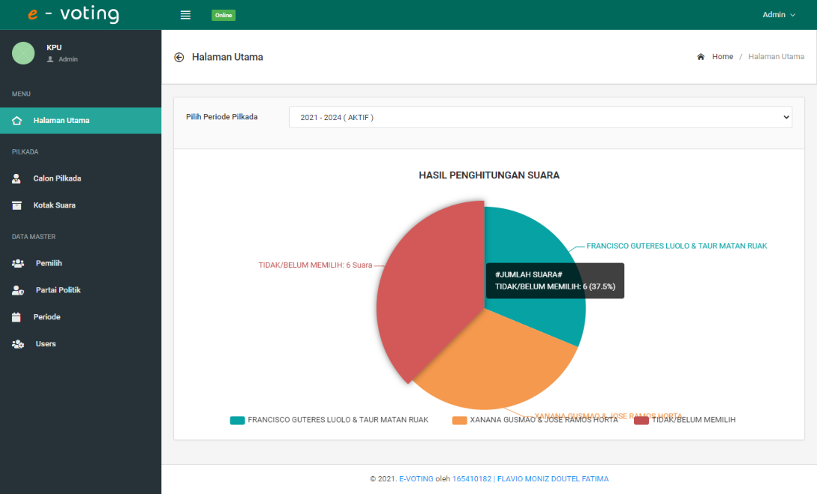

1. **Halaman Data Calon Pilkada**

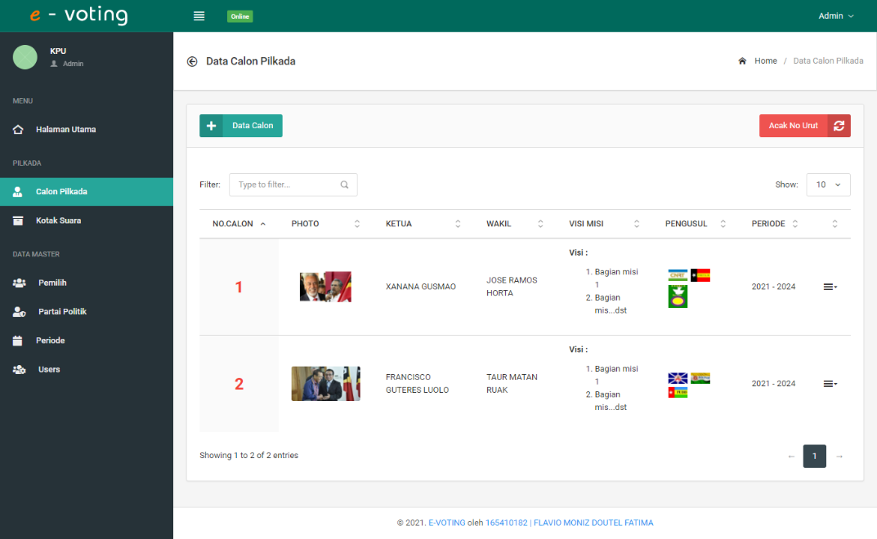

1. **Halaman Data Kotak Suara**

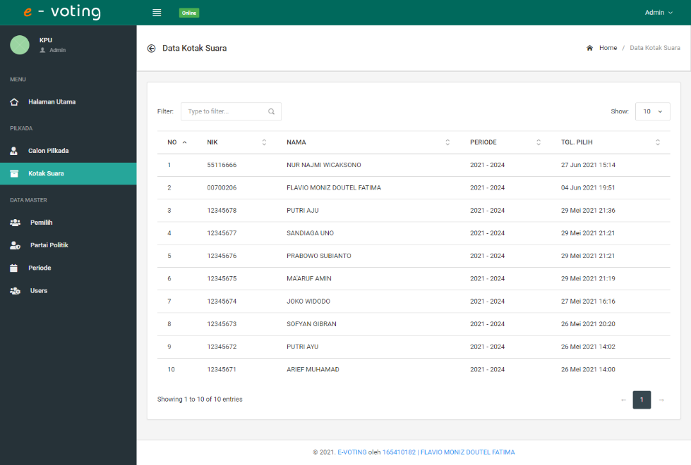

1. **Halaman Data Pemilih**

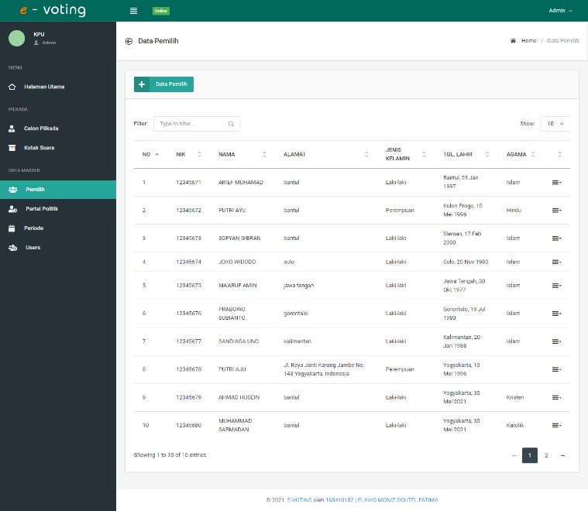

1. **Halaman Data Partai Politik**

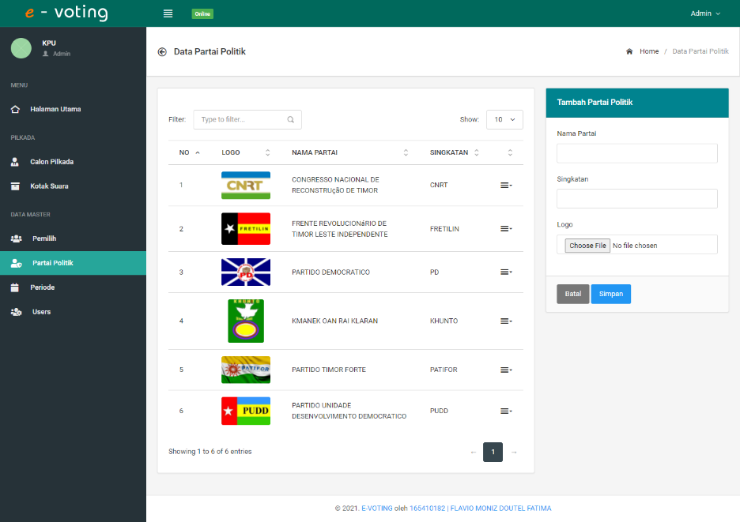

1. **Tampilan Data Periode**

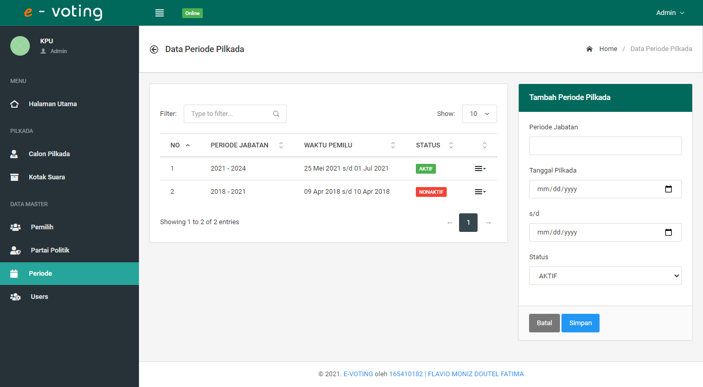

**LAMPIRAN QUERY DATABASE**

## **CalonModel.php**

|  |
| --- |
| <?php  class CalonModel extends CI_Model{  public function semuaCalon(){  $this->db->select('c.*,pr.periode_jabatan,(SELECT nama from pemilih WHERE id_pemilih=c.id_ketua) as nama_ketua, (SELECT nama from pemilih WHERE id_pemilih=c.id_wakil) as nama_wakil');  $this->db->from('calon as c');  $this->db->join('periode as pr', 'pr.id_periode=c.id_periode');  return $this->db->get()->result_array();  }  public function calonPeriodeAktif(){  $this->db->select('c.*');  $this->db->from('calon as c');  $this->db->join('periode as p', 'p.id_periode=c.id_periode');  $this->db->where('p.status', 'aktif');  $this->db->order_by('c.id_calon', 'RANDOM');  return $this->db->get()->result_array();  }  public function updateNoUrut($id_calon, $no_urut){  $this->db->where('id_calon', $id_calon);  $this->db->update('calon', ['no_urut' => $no_urut]);  }  public function calonById($id_calon){  $query = $this->db->get_where('calon', ['id_calon' => $id_calon]);  return $query->row_array();  }  public function tambahCalon(){  try {  $id_ketua = $this->input->post('id_ketua', true);  $id_wakil = $this->input->post('id_wakil', true);  $kategori = $this->input->post('kategori', true);  $id_periode = $this->input->post('id_periode', true);  $visi_misi = $this->input->post('visi_misi', true);  $id_kpu = $this->session->userdata('admin-iduser');  if ($kategori == "parpol") {  $parpol = $this->input->post('parpol');  $id_parpol = "";  foreach ($parpol as $p) {  $id_parpol .= $p . ',';  }  } else {  $id_parpol = NULL;  }  $photo = $this->_uploadImage(time());  $data = [  "id_ketua" => $id_ketua,  "id_wakil" => $id_wakil,  "photo" => $photo,  "visi_misi" => $visi_misi,  "kategori" => $kategori,  "id_periode" => $id_periode,  "id_parpol" => $id_parpol,  "id_kpu" => $id_kpu,  ];  $this->db->insert('calon', $data);  return true;  } catch (\SQLEXception $e) {  return false;  }  }  public function editCalon(){  try {  $id_calon = $this->input->post('id_calon', true);  $id_ketua = $this->input->post('id_ketua', true);  $id_wakil = $this->input->post('id_wakil', true);  $kategori = $this->input->post('kategori', true);  $id_periode = $this->input->post('id_periode', true);  $visi_misi = $this->input->post('visi_misi', true);  $photo_lama = $this->input->post('photo_lama', true);  $id_kpu = $this->session->userdata('admin-iduser');  if ($kategori == "parpol") {  $parpol = $this->input->post('parpol');  $id_parpol = "";  foreach ($parpol as $p) {  $id_parpol .= $p . ',';  }  } else {  $id_parpol = NULL;  }  if (!empty($_FILES["photo"]["name"])) {  $photo = $this->_uploadImage(time());  if ($photo_lama != "defaultcalon.png") {  $img_file = "./assets/images/calon/" . $photo_lama;  unlink($img_file);  }  } else {  $photo = $photo_lama;  }  $data = [  "id_ketua" => $id_ketua,  "id_wakil" => $id_wakil,  "photo" => $photo,  "visi_misi" => $visi_misi,  "kategori" => $kategori,  "id_periode" => $id_periode,  "id_parpol" => $id_parpol,  "id_kpu" => $id_kpu,  ];  $this->db->where('id_calon', $id_calon);  $this->db->update('calon', $data);  return true;  } catch (\SQLException $e) {  return false;  }  }  public function hapusCalon($id_calon){  try {  $this->db->delete('calon', ['id_calon' => $id_calon]);  return true;  } catch (\SQLException $e) {  return false;  }  }  private function _uploadImage($filename){  $config['upload_path'] = './assets/images/calon/';  $config['allowed_types'] = 'jpeg|jpg|png';  $config['file_name'] = $filename;  $config['overwrite'] = true;  $this->load->library('upload', $config);  if ($this->upload->do_upload('photo')) {  return $this->upload->data("file_name");  }  return "defaultcalon.png";  }  } |

## **PemilihModel.php**

|  |
| --- |
| <?php  class PemilihModel extends CI_Model{  public function semuaPemilih(){  $query = $this->db->get('pemilih');  return $query->result_array();  }  public function pemilihById($id_pemilih){  $query = $this->db->get_where('pemilih', ['id_pemilih' => $id_pemilih]);  return $query->row_array();  }  public function pemilihByNik($nik){  $query = $this->db->get_where('pemilih', ['nik' => $nik]);  return $query->row_array();  }  public function tambahPemilih(){  try {  $nik = $this->input->post('nik', true);  $nama = $this->input->post('nama', true);  $alamat = $this->input->post('alamat', true);  $jekel = $this->input->post('jekel', true);  $tempat_lahir = $this->input->post('tempat_lahir', true);  $tgl_lahir = $this->input->post('tgl_lahir', true);  $agama = $this->input->post('agama', true);  $data = [  "nik" => $nik,  "nama" => $nama,  "alamat" => $alamat,  "jekel" => $jekel,  "tempat_lahir" => $tempat_lahir,  "tgl_lahir" => $tgl_lahir,  "agama" => $agama,  ];  $this->db->insert('pemilih', $data);  return true;  } catch (\SQLEXception $e) {  return false;  }  }  public function editPemilih(){  try {  $id_pemilih = $this->input->post('id_pemilih', true);  $nama = $this->input->post('nama', true);  $alamat = $this->input->post('alamat', true);  $jekel = $this->input->post('jekel', true);  $tempat_lahir = $this->input->post('tempat_lahir', true);  $tgl_lahir = $this->input->post('tgl_lahir', true);  $agama = $this->input->post('agama', true);  $data = [  "nama" => $nama,  "alamat" => $alamat,  "jekel" => $jekel,  "tempat_lahir" => $tempat_lahir,  "tgl_lahir" => $tgl_lahir,  "agama" => $agama,  ];  $this->db->where('id_pemilih', $id_pemilih);  $this->db->update('pemilih', $data);  return true;  } catch (\SQLException $e) {  return false;  }  }  public function hapusPemilih($id_pemilih){  try {  $this->db->delete('pemilih', ['id_pemilih' => $id_pemilih]);  return true;  } catch (\SQLException $e) {  return false;}}} |

## **ParpolModel.php**

|  |
| --- |
| <?php  class ParpolModel extends CI_Model{  public function semuaParpol(){  $query = $this->db->get('parpol');  return $query->result_array();  }  public function parpolById($id_parpol){  $query = $this->db->get_where('parpol', ['id_parpol' => $id_parpol]);  return $query->row_array();  }  public function tambahParpol(){  try {  $nama_parpol = $this->input->post('nama_parpol', true);  $singkatan = $this->input->post('singkatan', true);  $slug = url_title($singkatan, 'dash', TRUE) . '-' . time();  $logo = $this->_uploadImage($slug);  $data = [  "nama_parpol" => $nama_parpol,  "singkatan" => $singkatan,  "logo" => $logo,  ];  $this->db->insert('parpol', $data);  return true;  } catch (\SQLEXception $e) {  return false;  }  }  public function editParpol(){  try {  $id_parpol = $this->input->post('id_parpol');  $nama_parpol = $this->input->post('nama_parpol', true);  $singkatan = $this->input->post('singkatan', true);  $slug = url_title($singkatan, 'dash', TRUE) . '-' . time();  $old_image = $this->input->post('logo_lama', true);  if (!empty($_FILES["logo"]["name"])) {  $logo = $this->_uploadImage($slug);  if ($old_image != "defaultlogo.png") {  $img_file = "./assets/images/parpol/" . $old_image;  unlink($img_file);  }  } else {  $logo = $old_image;  }  $data = [  "nama_parpol" => $nama_parpol,  "singkatan" => $singkatan,  "logo" => $logo,  ];  $this->db->where('id_parpol', $id_parpol);  $this->db->update('parpol', $data);  return true;  } catch (\SQLException $e) {  return false;  }  }  public function hapusParpol($id_parpol){  try {  $this->db->delete('parpol', ['id_parpol' => $id_parpol]);  return true;  } catch (\SQLException $e) {  return false;  }  }  private function _uploadImage($parpol){  $config['upload_path'] = './assets/images/parpol/';  $config['allowed_types'] = 'jpeg|jpg|png';  $config['file_name'] = $parpol;  $config['overwrite'] = true;  $this->load->library('upload', $config);  if ($this->upload->do_upload('logo')) {  return $this->upload->data("file_name");  }  return "defaultparpol.png";  }  } |

## **SuaraModel.php**

|  |
| --- |
| <?php  class SuaraModel extends CI_Model{  public function semuaSuara(){  $this->db->select('ks.*, p.nama as nama_pemilih, p.nik, c.*, pr.*');  $this->db->from('kotak_suara as ks');  $this->db->join('pemilih as p', 'p.id_pemilih=ks.id_pemilih');  $this->db->join('calon as c', 'c.id_calon=ks.id_calon');  $this->db->join('periode as pr', 'pr.id_periode=ks.id_periode');  $this->db->order_by('ks.tgl_pilih', 'DESC');  return $this->db->get()->result_array();  }  public function jumlahSuara($id_periode){  $this->db->select('ks.id_calon,(SELECT nama FROM pemilih WHERE id_pemilih=c.id_ketua) AS nama_ketua,  (SELECT nama FROM pemilih WHERE id_pemilih=c.id_wakil) AS nama_wakil,  COUNT(*) AS jml_suara');  $this->db->from('kotak_suara AS ks');  $this->db->join('periode AS pr', 'pr.id_periode=ks.id_periode');  $this->db->join('calon AS c', 'c.id_calon=ks.id_calon');  $this->db->where('pr.status', 'aktif');  $this->db->where('pr.id_periode', $id_periode);  $this->db->group_by('ks.id_calon');  $jml_memilih = $this->db->get()->result_array();  $jml_tidak_memilih = $this->tidakMemilih($id_periode);  $data = array_push($jml_memilih, $jml_tidak_memilih);  return $jml_memilih;  }  public function tidakMemilih($id_periode){  $this->db->select('((SELECT COUNT(*) FROM pemilih) - (SELECT COUNT(*) FROM kotak_suara WHERE id_periode=' . $id_periode . ')) AS jml_suara');  return $this->db->get()->row_array();  }  } |

**LAMPIRAN GAMBAR RELASI TABEL**

